

|  |  |  |  |  |  |  |  |  |
| --- | --- | --- | --- | --- | --- | --- | --- | --- |
|  | | | | | | | | |
|  | | Lab 05 | Using Social Engineering Techniques to Plan an Attack | | | | |  | |
|  |  | | | | | | |  |
|  | | | |  |  | | | |
|  | | | | Cesar Munguia |  | | | |
|  | | | | 11/26/2023—IS-3423-003—Darniet Jennings |  | | | |
|  | | |  | | |  | | |



|  |  |  |  |  |  |  |  |  |
| --- | --- | --- | --- | --- | --- | --- | --- | --- |
|  |  | | |  |  | | |  |
|  | Learning Objectives | | | | | | |  |
|  |  | | |  |  | | |  |
|  |  | |  | | |  | |  |
|  |  |  | Upon completing this lab, you will be able to:   1. Recognize some of the key characteristics of a social engineering attack. 2. Identify some of the key signs of a reverse social engineering attack. 3. Describe the differences and similarities of an attack of convenience and a targeted attack. 4. Implement countermeasures to social and reverse social engineering attacks. 5. Conduct passive reconnaissance in preparation for a social engineering attack. 6. Use malicious code and phishing techniques as part of a social engineering attack. 7. Investigate an insider threat. | | |  |  |  |
|  | | | | |
|  |  |  |  |
|  |  |

# Section 1: Hands-On Demonstration

### Part 1: Observe Targeted Social Engineering Research

1. On the vWorkstation taskbar, **click** the **File Explorer icon** to open the File Explorer.
2. In the File Explorer, **navigate** to the Lab_files folder (**This PC > Local Disk (C:) > SE_Lab_files > Lab_files**) and **double-click** the **website.pdf** **icon** to see the result of the browser search.
3. **Close** the **website.pdf** **file**.
4. In the Lab_files folder, **double-click** the **contact.pdf icon** to open the Contact Us page.
5. **Close** the **contact.pdf** **file**.
6. In the Lab_files folder, **double-click** the **whois.pdf icon** to see the whois.net results for Global Enterprises.
7. **Make a screen capture** showing the **whois information for Global Enterprises**.

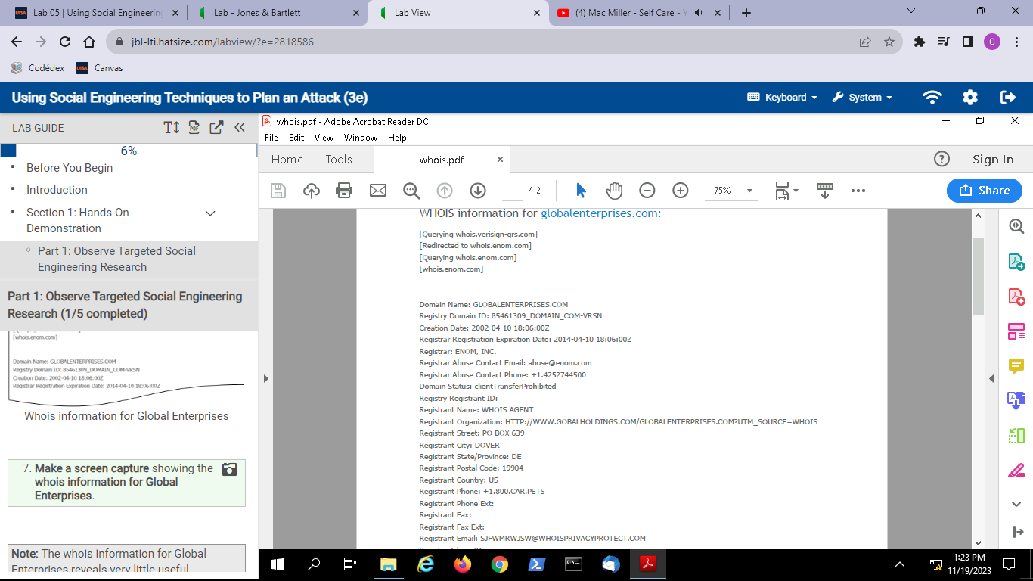

1. **Close** the **whois.pdf file**.
2. In the Lab_files folder, **double-click** the **getconnected.pdf icon** to open the results of a search for Global Enterprises in the fictitious business networking site, GetConnected.com.
3. **Close** the **getconnected.pdf file**.
4. In the Lab_files folder, **double-click** the **profile.pdf icon** to review LouAnne Garfinkle’s GetConnected profile.
5. **Make a screen capture** showing **LouAnne’s GetConnected profile**.

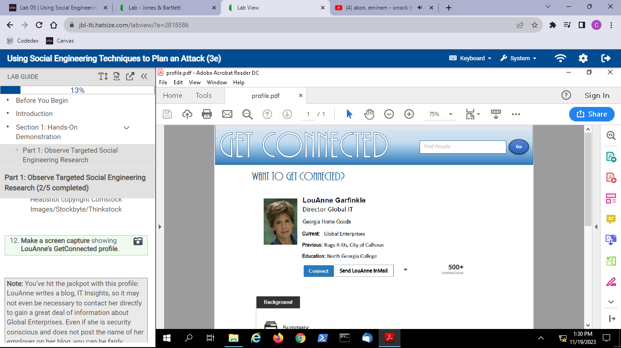

1. **Close** the **profile.pdf file**.
2. In the Lab_files folder, **double-click** the **blog1.pdf icon** to open the first important blog entry.
3. **Make a screen capture** showing the **first blog entry**.

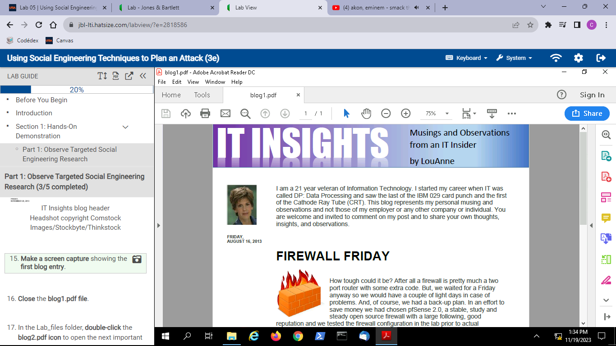

1. **Close** the **blog1.pdf file**.
2. In the Lab_files folder, **double-click** the **blog2.pdf icon** to open the next important blog entry.
3. **Make a screen capture** showing the **second blog entry**.

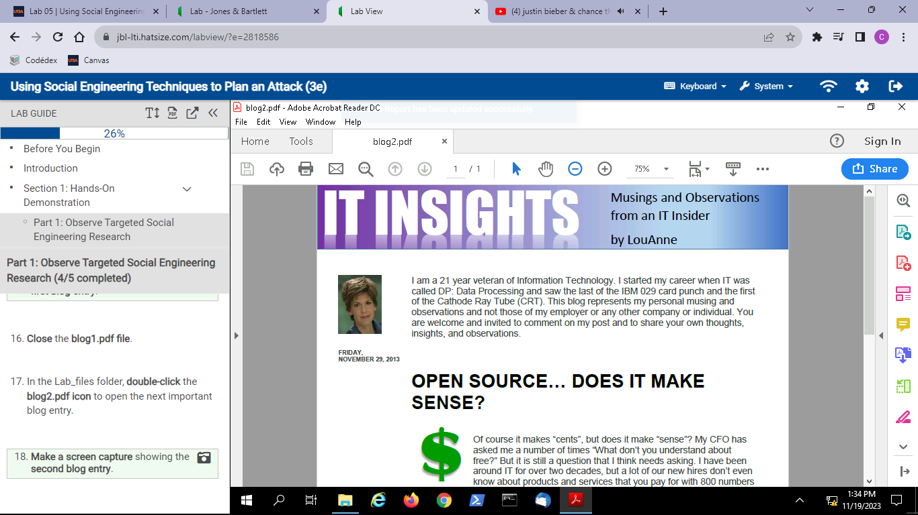

1. **Close** the **blog2.pdf file**.
2. On your local computer, **open** a **new browser tab** and **navigate** to **your preferred search engine**.
3. **Perform a search** to find the current version of the **firewall software** used by Global Enterprises.
4. **Record** the **current firewall software version number**.

PfSense current firewall software version number is 2.7.1

### Part 2: Observe a Targeted Reverse Social Engineering Attack

1. In the Lab_files folder, **double-click** the **ad.pdf icon** on the vWorkstation desktop to view the details of the job ad.
2. **Make a screen capture** showing the **fake job ad**.

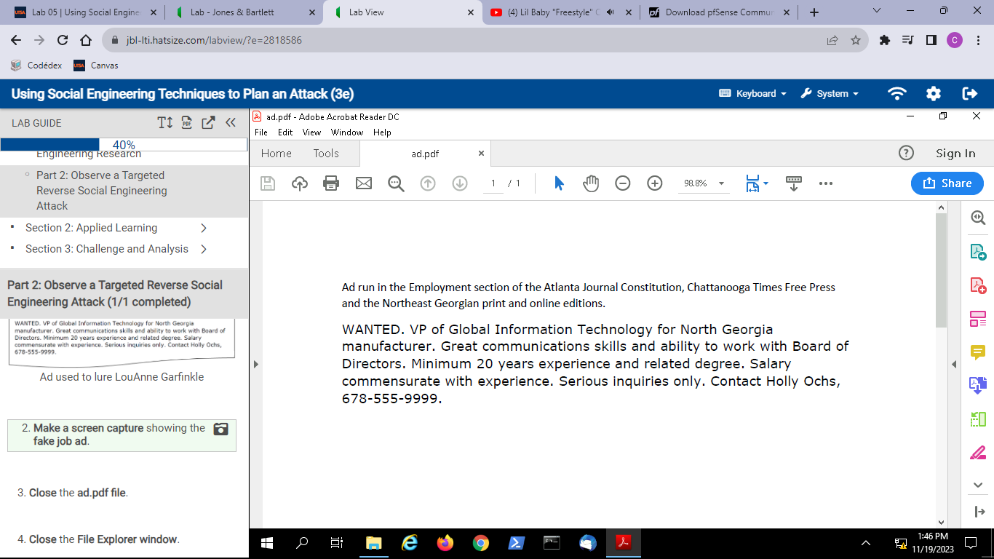

1. **Close** the **ad.pdf file**.
2. **Close**the**File Explorer window**.

# Section 2: Applied Learning

### Part 1: Perform Targeted Social Engineering Research

1. From the vWorkstation taskbar, **launch Chrome**and **navigate**to **http://www.corporationtechs.com**.
2. **Make a screen capture** showing the **services offered by Corporation Techs**.

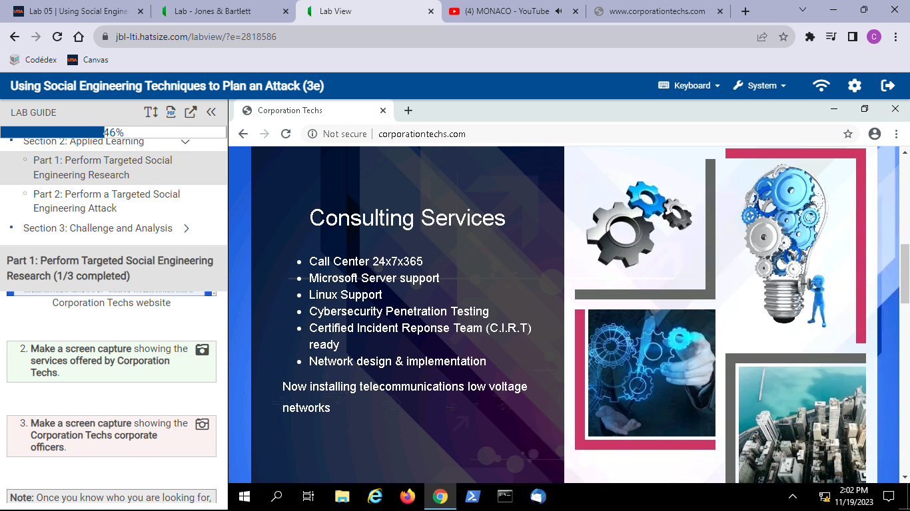

1. **Make a screen capture** showing the **Corporation Techs corporate officers**.

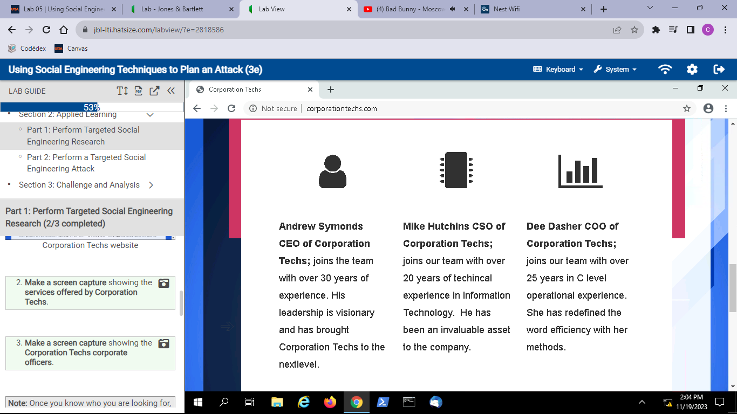

1. On your local computer, **open** a new **browser tab** and **navigate** to the LinkedIn website at **http://www.linkedin.com** and **log in** with your own user credentials. The virtual machines in this environment do not have Internet access; ensure you are completing this in your own browser on your local machine.
2. Using the LinkedIn search tool, **search** for a profile **for each of the officers** of Corporation Techs. A direct link to each of the officers' profiles is included here.

* Andrew Symonds – <https://www.linkedin.com/in/andrew-symonds-72019b146/>
* Mike Hutchins – <https://www.linkedin.com/in/mike-hutchins-9351a0146/>
* Dee Dasher – <https://www.linkedin.com/in/dee-dasher-4901a0146/>

1. Review the LinkedIn profiles and answer the following questions.

* Which college or university did each officer attend, and for which years? Andrew Symonds went to San Diego University and it does not state which years, Mike Hutchins went to Virginia Tech from 1992 to 1996, and Dee Dasher went to Texas State University from 1985 to 1989.
* Where does each officer live? The all live in Addison, Texas.
* Not including Corporation Techs, where did each officer work the longest? Andrew Symonds at Wodash Incorporated, Mike Hutchins at Aegis Secured, and Dee Dasher at Dante’s Inc.

### Part 2: Perform a Targeted Social Engineering Attack

1. On the corporationtechs.com website, **complete** the **Contact Us form** using the following information., then **click** the **Submit button**.

* First Name: ***yourfirstname***, where *yourfirstname* is replaced with your own first name (or a fake name if you prefer; this information is not retained anywhere)
* Last Name: ***yourlastname***, where *yourlastname* is replaced with your own last name (or a fake name if you prefer; this information is not retained anywhere)
* Email Address: [**bobs@securelabsondemand.com**](mailto:bobs@securelabsondemand.com)
* Company Name: **Secure Labs on Demand**
* Comments: **I would like to know more about your services.**

1. From the vWorkstation desktop, **open** the **Thunderbird application** and **locate** the email sent by this web form.
2. **Make a screen capture** showing the **contents of the email.**

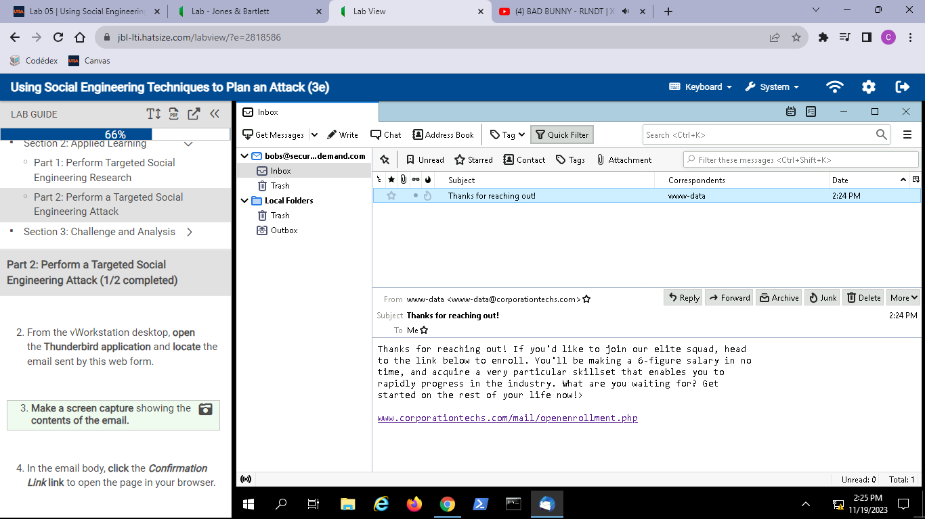

1. In the email body, **click** the ***Confirmation Link*** **link**to open the page in your browser.
2. **Make a screen capture** showing the **resulting web page**.

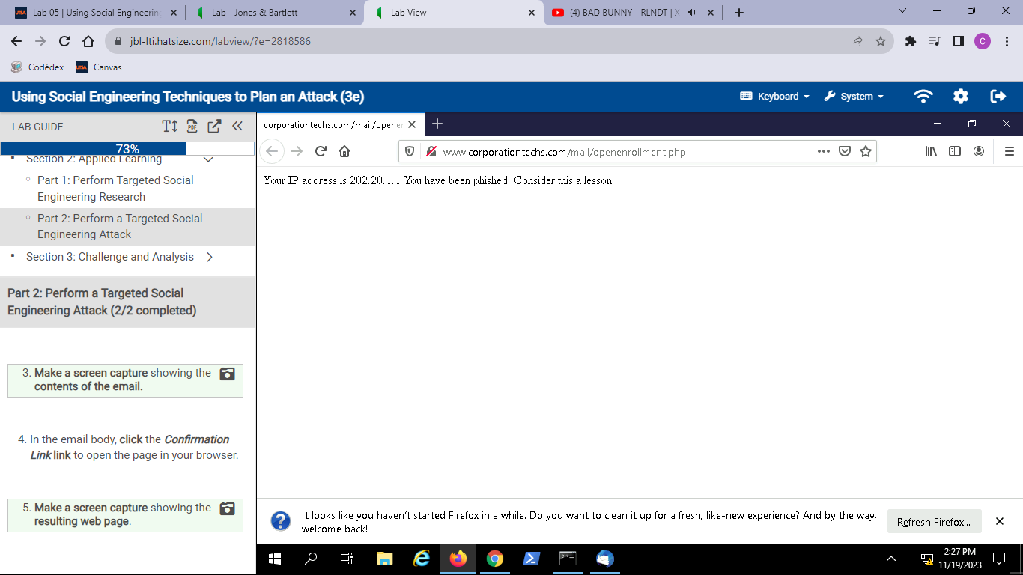

# Section 3: Challenge and Analysis

### Part 1: Investigate a Data Leak

1. From the vWorkstation Start menu, **launch** a new **Command Prompt window**.
2. At the command prompt, **execute nmap -sV -Pn –script=http-enum www.corporationtechs.com** to issue an Nmap scan of the web server for open ports and enumerate any directories. The results confirm that port 80 (HTTP) is open, and also reveals that the web server is an Apache server.
3. **Make a screen capture** showing the **results of the Nmap scan**.

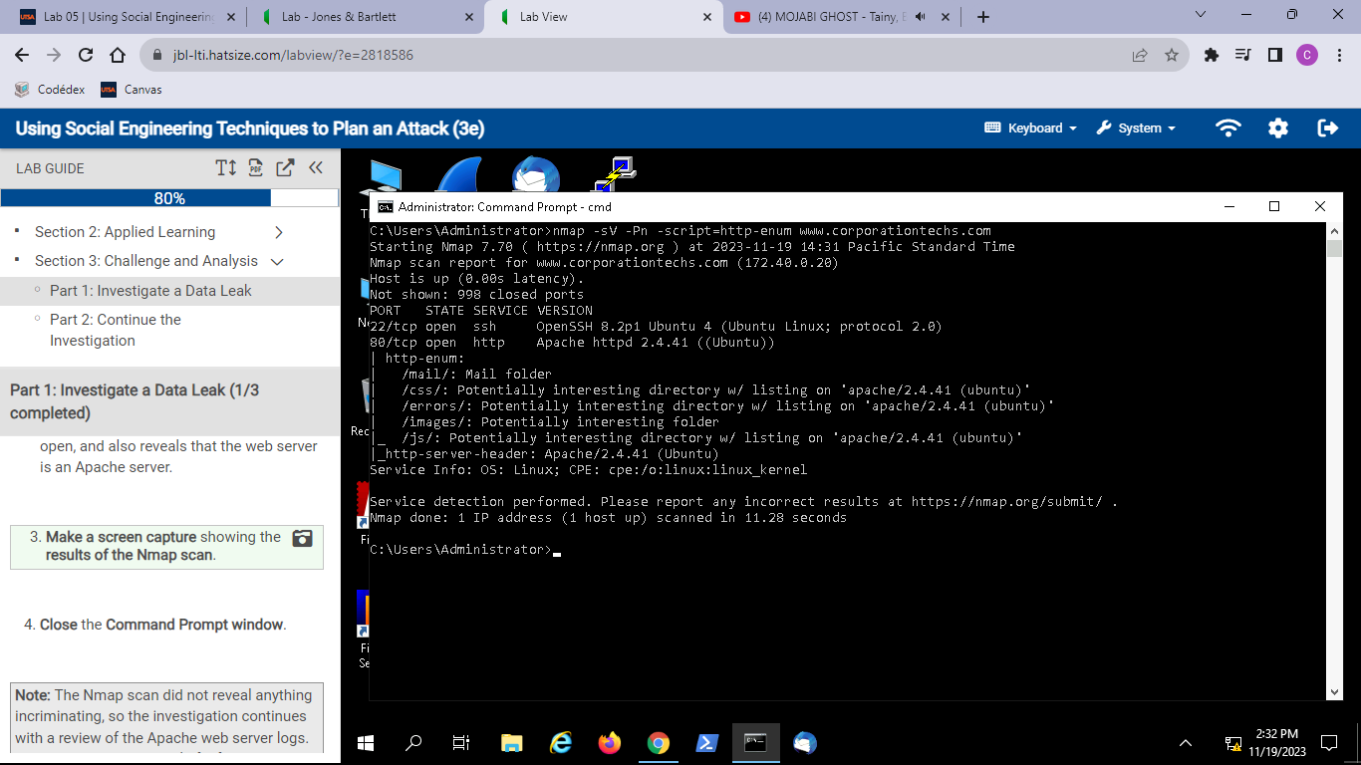

1. **Close**the **Command Prompt window**.
2. From the vWorkstation taskbar, **launch** the **File Explorer** and **navigate** to the SE_Lab_files folder (**This PC > Local Disk (C:) > SE_Lab_files**). The folder contains two files: apache2_access.log and Apache2_access_log.xlsx.
3. **Open** the **apache2_access.log file** and **review** **the format** of the log data. Try to identify IP addresses, times and dates, and the content being captured to get a sense of the structure.
4. **Close** the **apache2_access.log file**.
5. **Open** the **Apache2_access_log.xlsx file** and **review the format** of the log data. This file contains the same log data as the first, but it is presented in Excel to make it easier to read. This log file is a real web log from the corporationtechs.com web server.
6. In the Apache2_access_log.xlsx file, use the Excel Find feature to **search** for the **pricesheet.xlsx file**.
7. If the file is found, **continue to step 12**.
8. If the file is not found, **repeat step 9** using different variations of the file name until you locate a reasonable match. You will notice that the original file name, pricesheet.xlsx does not appear in the log file, but there is a file name that closely matches. Now you know that the file is in fact being leaked from the web server. You will need to investigate the web page itself to learn more.
9. **Open** a new **Chrome window** and **navigate** to **corporationtechs.com**.
10. On the Corporation Techs home page, **right-click** any open space and **select Inspect**from the context menu to open the Inspector pane.
11. **Review** the code in the Inspector pane until you find the **file name you identified earlier**.
12. **Make a screen capture** showing the**script that will open the file**.

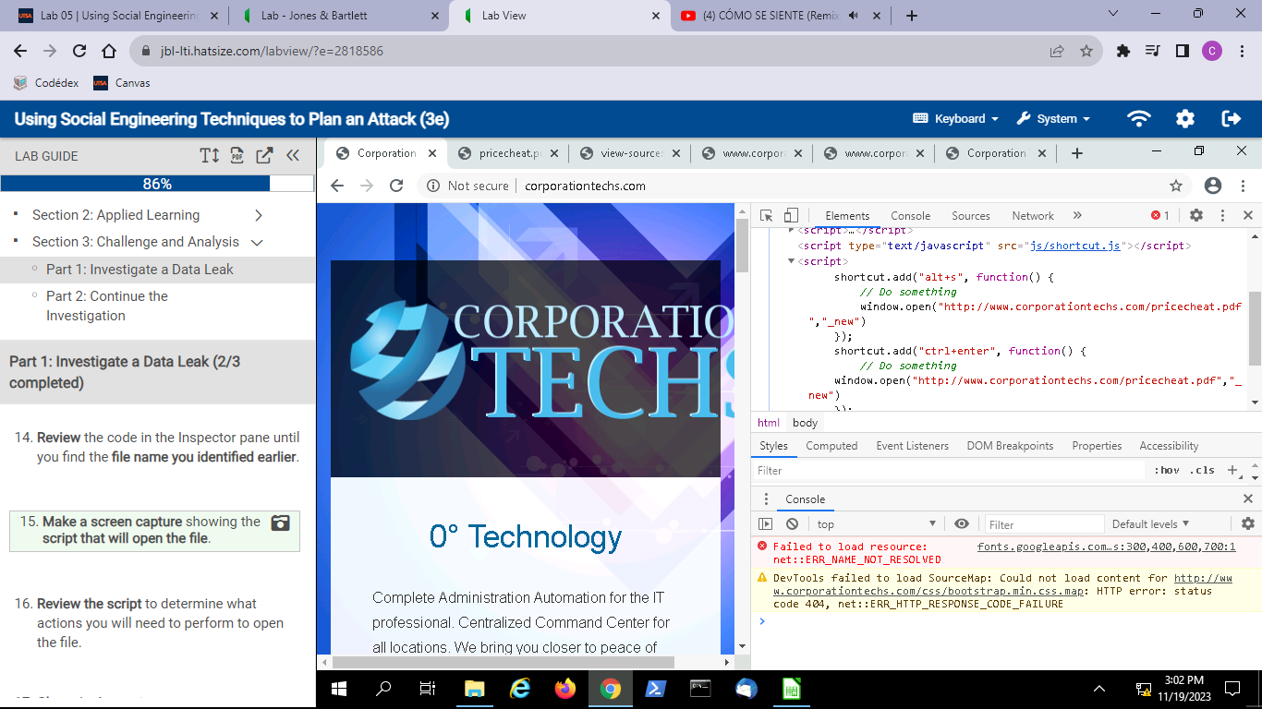

1. **Review the script** to determine what actions you will need to perform to open the file.
2. **Close**the **Inspector pane**.
3. On the Corporation Techs website, **complete the actions** required to open the file. You now know how the bid information is being passed to the competitor, although you still don’t know who is responsible for leaking the information.
4. **Make a screen capture** showing the**result of your actions**.

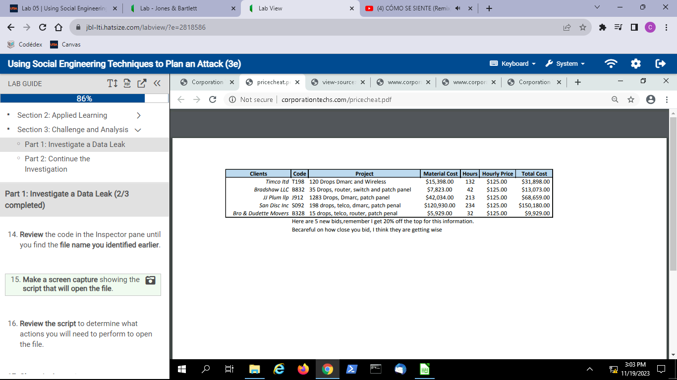

1. **Close**any**open windows**.

### Part 2: Continue the Investigation

In Part 1, you followed an investigation to discover how the information in the pricesheet.xlsx file was being transferred to Corporation Techs’ biggest competitor. Now that you know how the information was being transferred, your mentor has asked you what you would do to continue the investigation and catch the culprit? Would you rely on technical measures such as digital forensics to determine who was posting the files? Could you apply social engineering techniques to this scenario?

* **Write a brief summary** of your recommendations.

My recommendations would be to first look at the IP address that had accessed the .pdf file and try to trace them down, so basically, the IP addresses who have done what the script stated in order to get the file. This would give us a better idea of the potential external suspects. Then, my second recommendation would be to implement digital forensics, like looking at logs to see when the code of the web page was last modified and by what user.